Asian Parliamentary Assembly
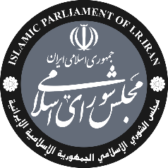 | Standing Committee on  Political Affairs  Mashhad, Iran  3-6 December 2025 | 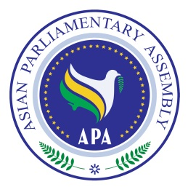
Registration Form
- 23 November 2025, the deadline for submission of registration form.

Delegation of:
Name of Parliament
 | Date | Airline & Flight number | Time | Explanation
Arrival
Departure

No. | Delegation Information | Photo
1 | First Name: Last Name:  Passport No:  Passport issue date: Passport expiry date:  Date of birth (d/m/y): Place of birth (City, Country):  Head of delegation    Phone: Email:
2 | First Name: Last Name:  Passport No:  Passport issue date: Passport expiry date:  Date of birth (d/m/y): Place of birth (City, Country):  Member of delegation  Phone: Email:
3 | First Name: Last Name:  Passport No:  Passport issue date: Passport expiry date:  Date of birth (d/m/y): Place of birth (City, Country):  Member of delegation  Phone: Email:
4 | First Name: Last Name:  Passport No:  Passport issue date: Passport expiry date:  Date of birth (d/m/y): Place of birth (City, Country):  Staff  Phone: Email:
Host Secretariat: | CC to APA Secretariat:
int.conference.dept@parliran.ir  Tel: +9821-33440322  +9821-334403307  Fax: +9821-33440321 | Email : secretariat@asianparliament.org  Fax: (+98-21) 33517408  Phone: (+98-21) 33517406-7  CC: Majlisprotocoldept@parliran.ir

